***Final Assessment Screenshots***

**Final Assessment Devops(Maven,Junit, Git,Sonarqube,Docker,Jenkins) implementation for Microservice Customer Producer application**

a)Push the code through IDE STS into github remote repository backend.

<https://github.com/SBiswajeet/Week4>

1)Back-end code pushed to git:

2. Push Front End code also into GIT Command Line

b) Running the possible number of Junit test Case (Positive+ Negative-)

1)JNUIT TEST CASES AND COVERAGE:

2)H2 CONSOLE:

c)Devops:

Code quality can be checked for backend code

d) SONARQUBE

1)PROJECT IMPORTED TO SONARQUBE

2)BUGS AND VULNERABILITIES IN SONARQUBE

e)RDS

1)RDS INSTANCE:

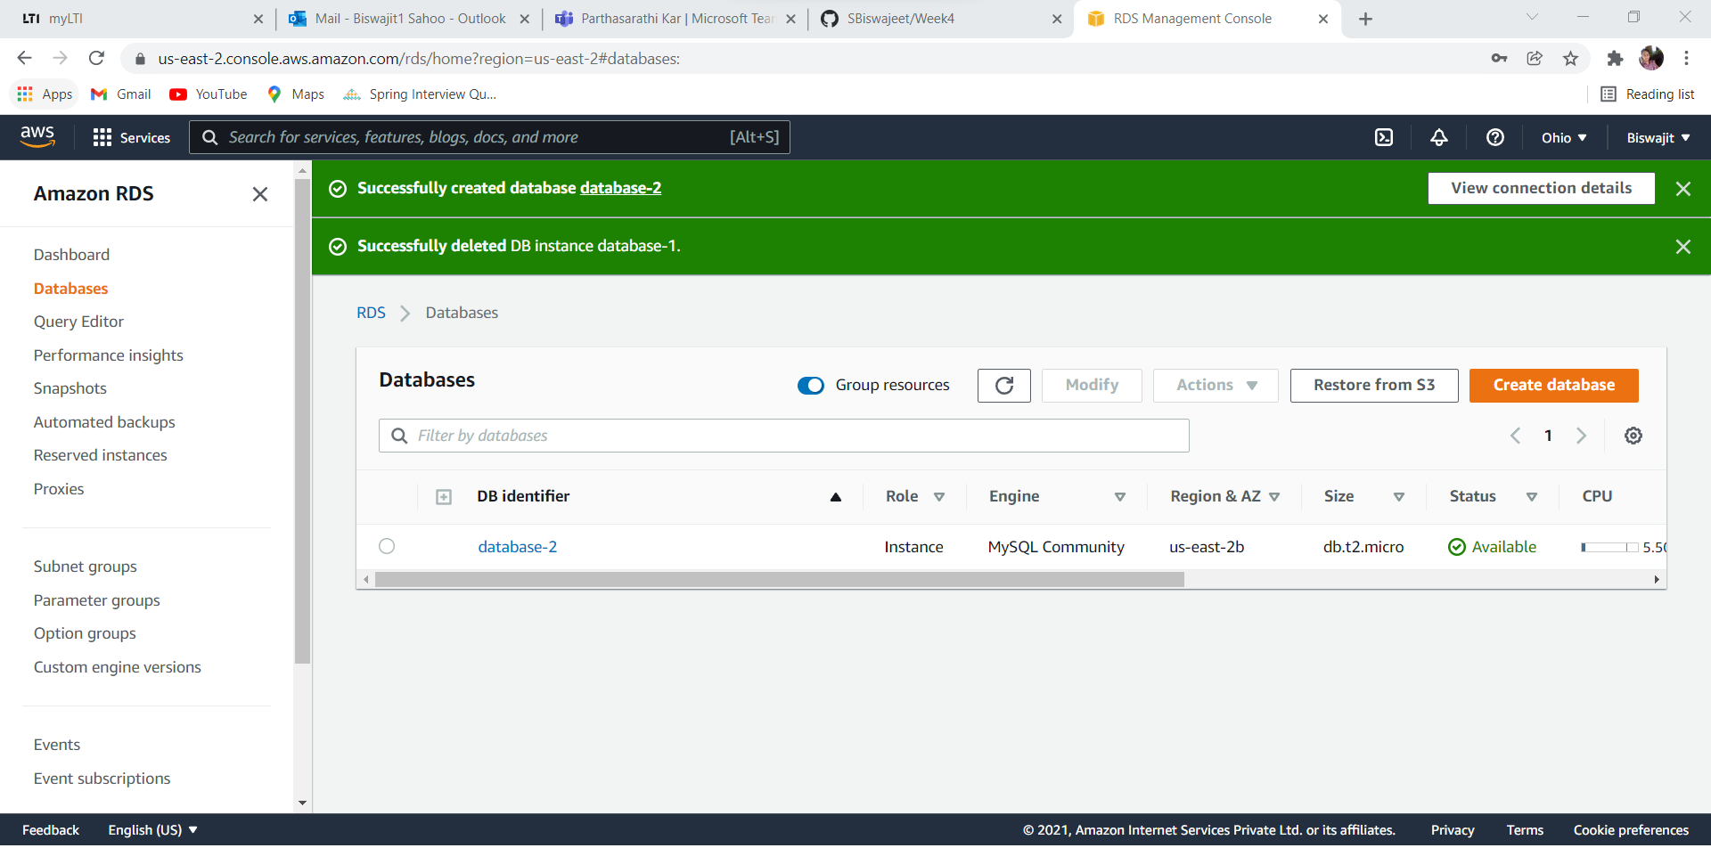

Endpoint & port

database-2.ceriaktrp50y.us-east-2.rds.amazonaws.com

Port:3306

2)RDS INSTANCE CONNECTED TO MYSQL:

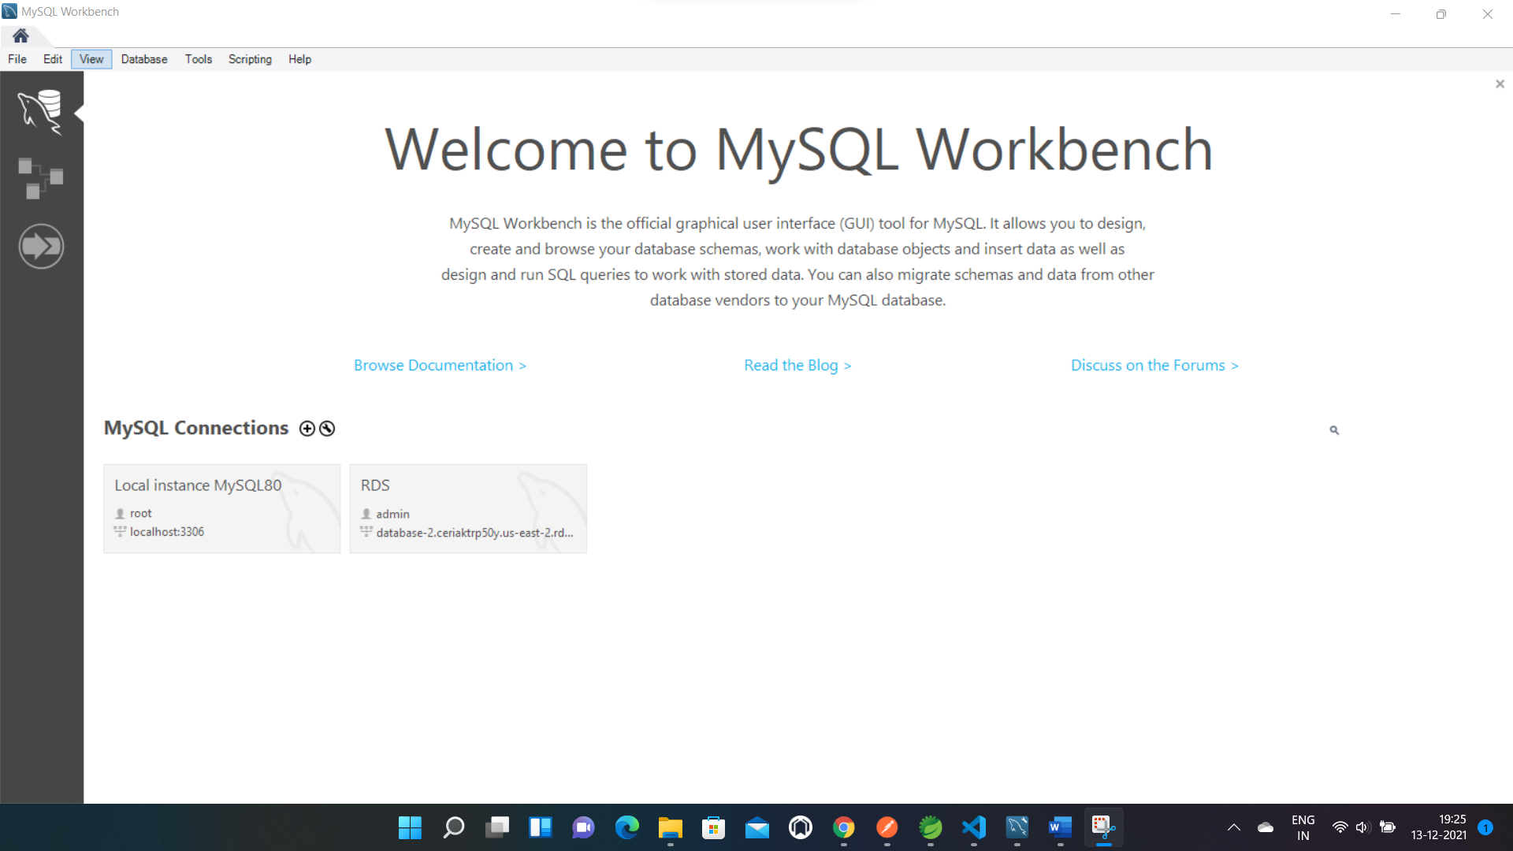

f)EC2 INSTANCE:

g)Docker Running from EC2-INSTANCE

h)JENKINS FRUNNING FROM EC2 INSTANCE

1. S3 INSTANCE:

s3 bucket: arn:aws:s3:::week4assessmentfrontend

j)View

1)Frontend view for Add customer

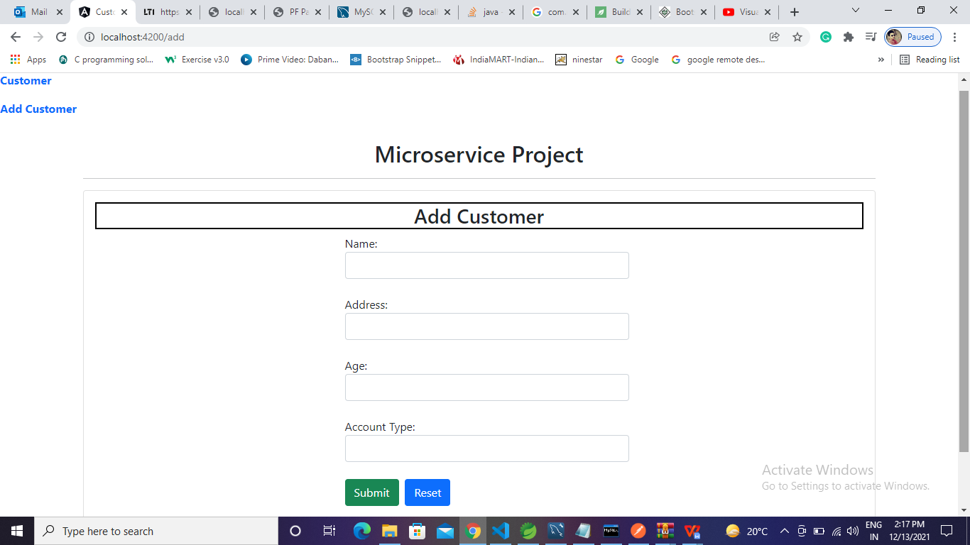

2)Frontend view for Details Customer

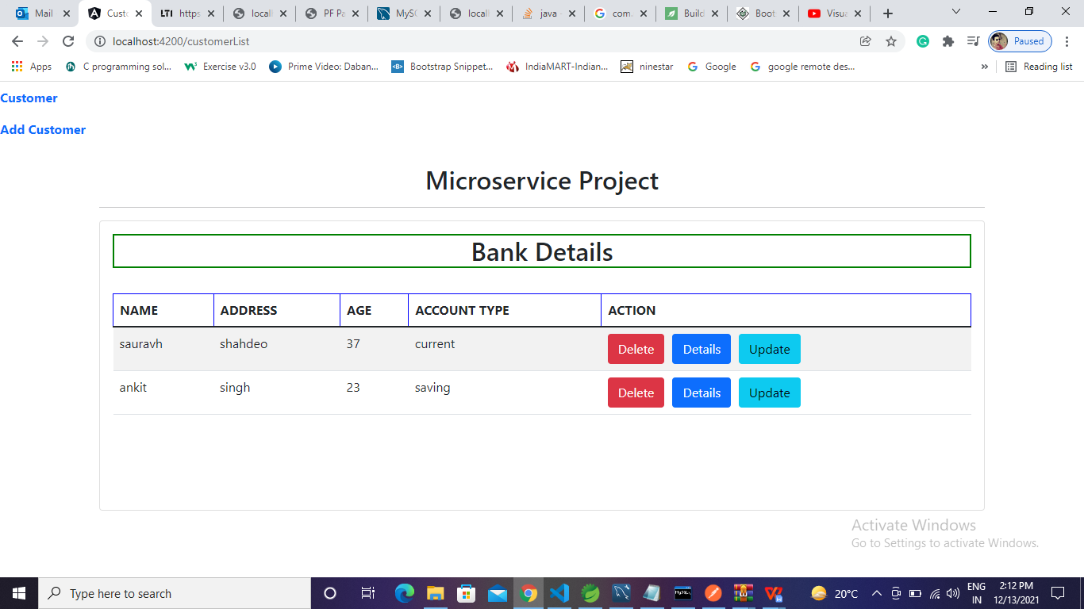

k)JENKINS:

l)Docker from Putty:

